The Bodger’s Guide to …………..
Using ceramic flange mount devices in the G4BAO 23cm LDMOS Power Amplifier PCB

Introduction
A number of people have asked me if it is possible to use the older bolt-down ceramic versions of the MRF9045 in my PCB. Well the answer is yes, with one caveat. Common source LDMOS amplifiers require a very low-inductance connection from the source of the device to ground. Any extra inductance and the devices become power oscillators and quickly destroy themselves.

The G4BAO PCB was designed for the plastic devices that solder to a small heat spreader, which is itself soldered direct to the underside ground plane on the PCB. This then forms the lowest inductance connection possible, leaving you with a stable amplifier. A consequence of this is that the PCB design has no grounding vias close to the device itself. Simply cutting a longer hole in the PCB to make space for the flange results in an amplifier in which it is impossible to set the quiescent bias current; turning up the gate voltage results in the device “snapping on” and taking LOTS of drain current, eventually destroying itself.
Power pins
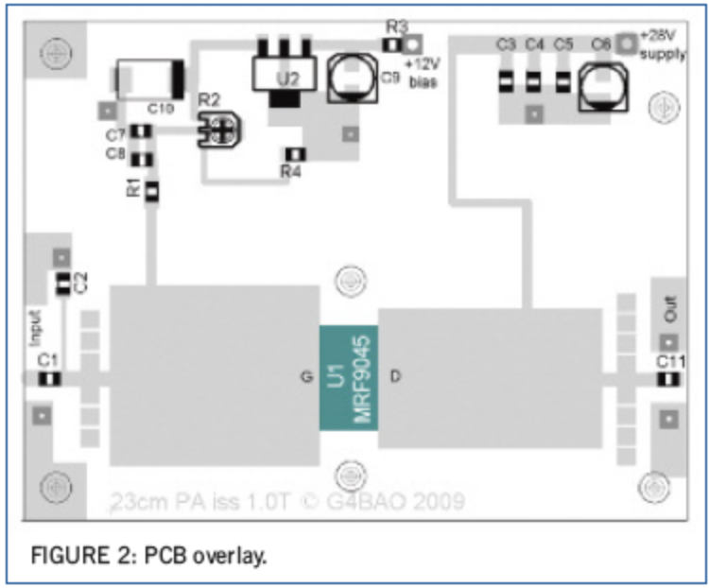
Plated through holes

Plated through holes
Figure 1 - existing PCB overlay

The Bodger’s solution
To make a good connection between the mounting flange and the ground plane it is a case of simply soldering the flange to the ground plane as shown in Figure 3.

Bodger’s rant
At this point I’d like to “bang on” about home constructors buying a decent soldering iron. I own one soldering station. It’s a temperature controlled OKI/Metcal that with just a bit change is capable of soldering everything from tinplate boxes and LDF5-50 connectors down to 0402 smd components.
OK so it cost nearly £150, but I reckon you only buy one or two irons in your life if you look after them, and the spares are available easily.
You end up with “Trigger’s” road broom from “Only Fools and Horses, (“This brush is amazing, it’s lasted years… it’s had four new heads and two new handles!)

The point is, if you get a decent temperature controlled iron that automatically turns up the power to solder big things, you are most unlikely to damage devices from overheating, or to not have enough “grunt” to solder a copper heat spreader down.

Back to the modification
Simple, you lengthen the slot (U1 in Figure 1 above) so that it is long enough to accommodate the flange device centrally. Figure 2 shows the topside of the PCB with the device fitted, and Fig 4 shows where to solder the flange down to the ground plane

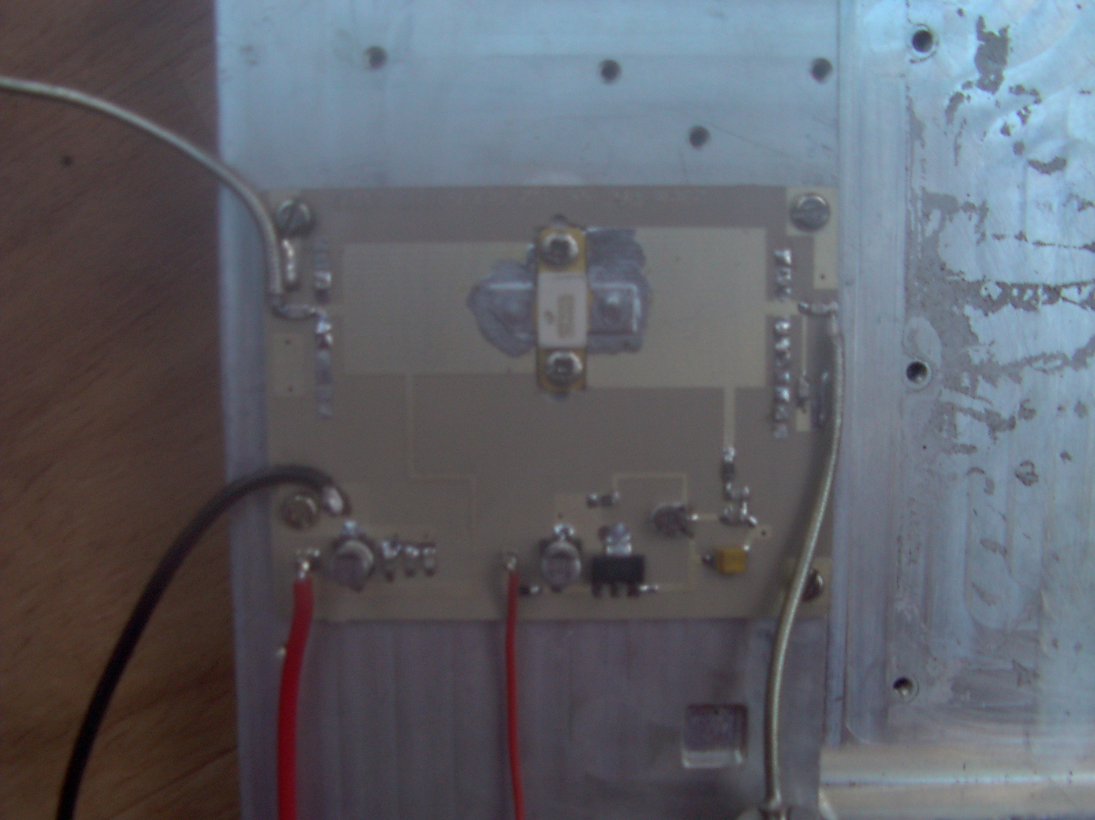
Figure 2 Topside with ceramic device fitted

. 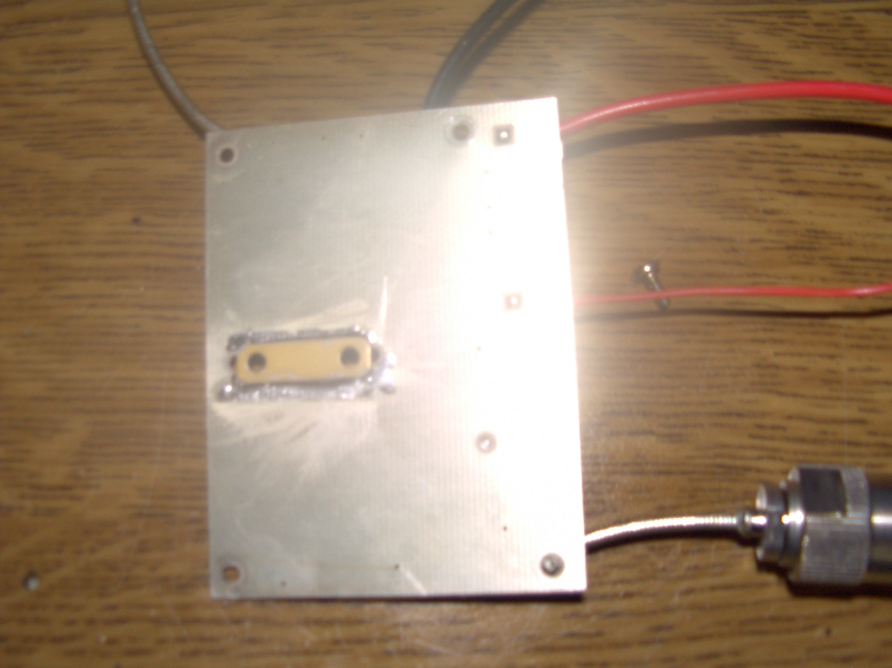
Figure 3 Underside showing soldered flange

