IPAM PA to 13CMs

As provided the PA shows great potential for 13CMs. The output stages consisting of four MFR6S21100HS’s. Though the devices are in theory capable of generating 400W of RF, it must be pointed out that the output hybrid is only rated at 120W continuous. Talk too much and the hybrid will burn out.

In its designed service, the PA runs off 50V, +ve earth and will function as provided but due to the control circuit, it will back off when it reaches a certain output.

Conversion to 28V

Conversion just isn’t place 28V where the output of the internal 50 to 28V SM PSU was. The PA will not function on 28V alone, there is an 8V regulator on the SM PSU. This feeds from the 28V output of the SM PSU and is used for the bias and control board supplies.

I did try removing the SM PSU module from the PCB, but blew the +8V switching regulator. So ended up completely removing the SM PSU PCB and inserting a 7808 feed from the new 28V input.

28V Feed Point

Though there is a connector on the PA board, each of the pins are only rated to 1A. So this was completely removed and the 28V wire soldered directly to the PCB. Don’t forget the 8V feed to be connected as well; this goes in pin 10 of the power connector.
+ve 28V pins 1 to 8; -ve 28V pins 11-20

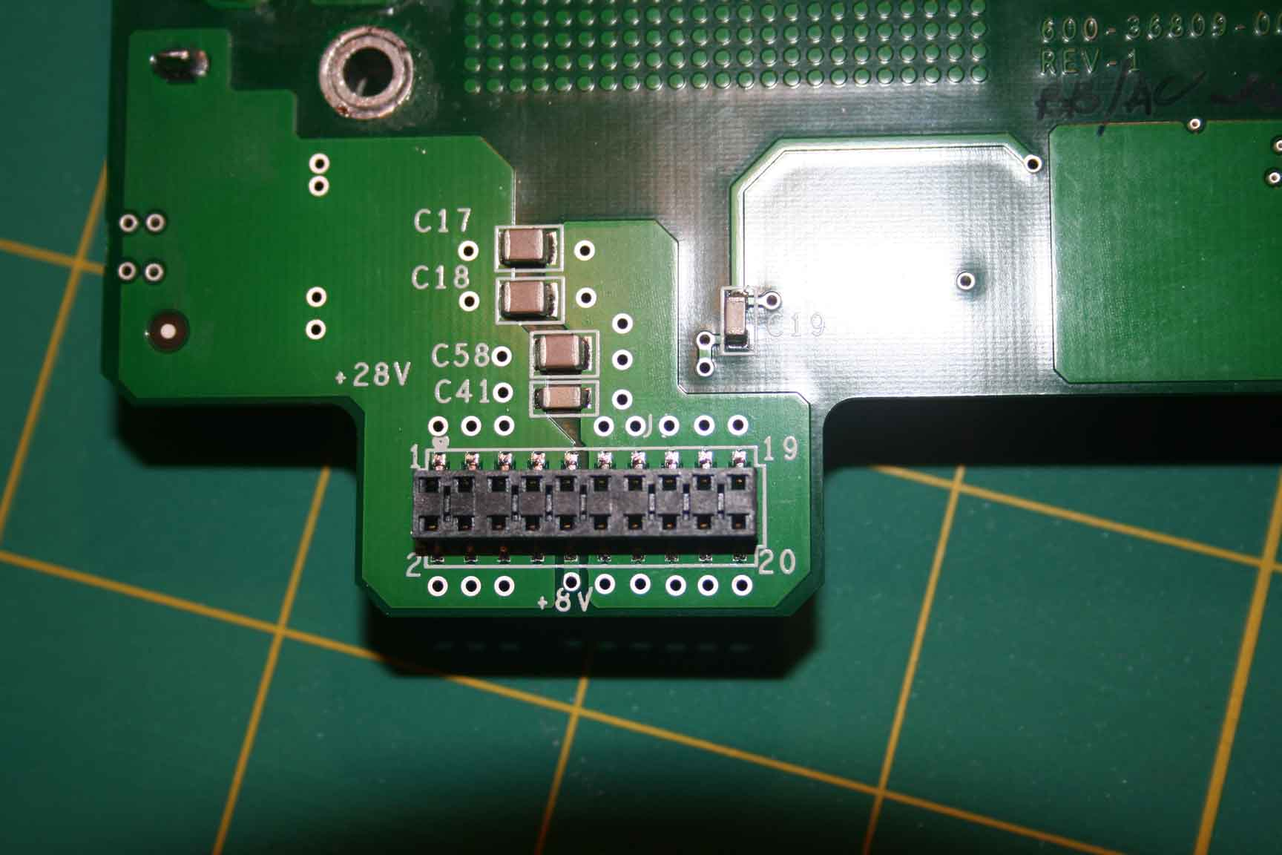

Disabling the Control Board

As it stands, there is a 20-way ribbon cable running from the PA to the Control PCB at the front. If the board/cable is removed, then the PA won’t function, as there are a number of volts required down some of the control wires.

I made a ‘break-out’ box to enable the various pins to be monitored and where necessary pulled high etc.

Looking at the control board, which has a 32-pin connector on it. Only the first 20 pins are used. The numbering of the pins is on the board. Odd numbers towards the front panel and even towards the back.

Once the control wires were identified, it was easier, with the aid of a scalpel, to cut the relevant wires in the ribbon cable.

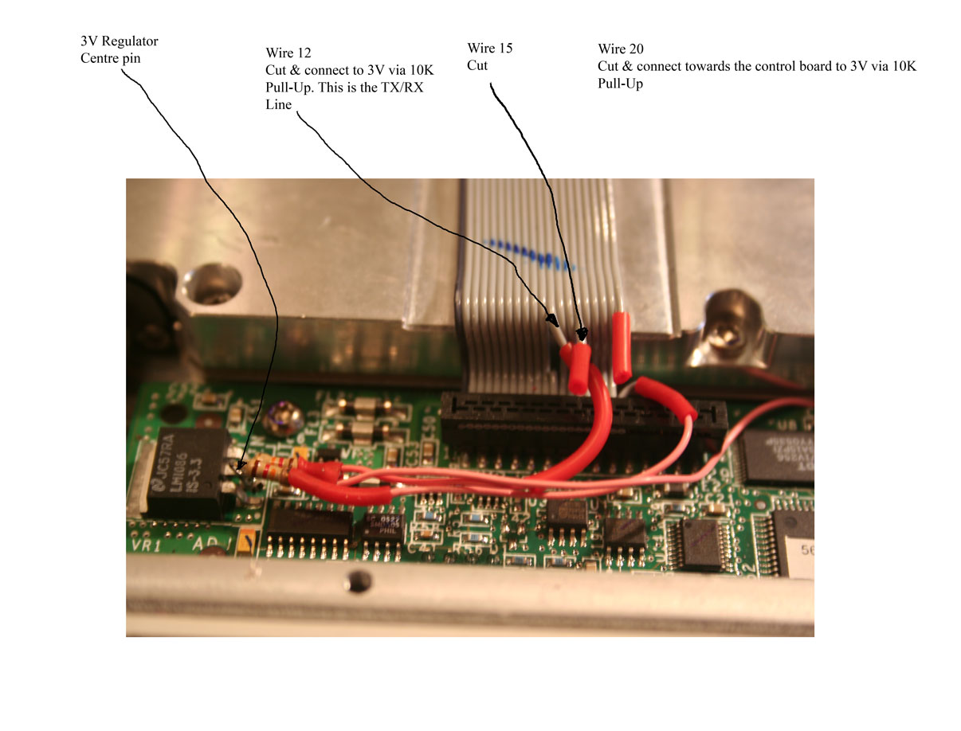

Pin 1 is the black wire on the ribbon cable

Pin 12 – Cut the wire, on the ribbon cable towards the PA place 10K pull-up resistor to 3V (there is a 3V regulator to the left of the board when looking from the front. Centre pin is 3V) This is the TX/RX lead. Short to earth to TX.

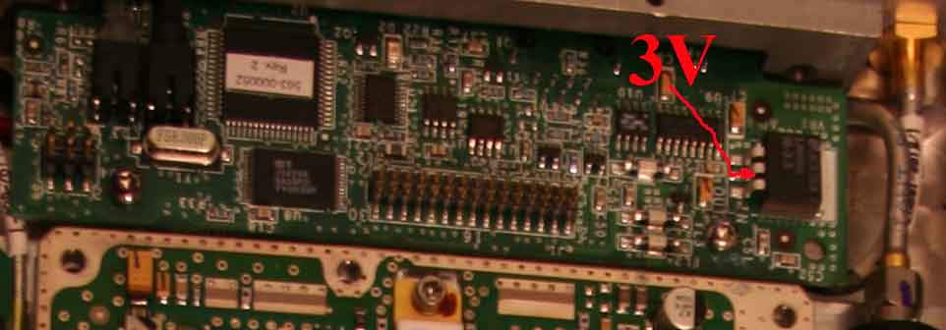

Pin 20 – disconnect wire and pull up to 3V via a 10K resistor (it was handy at the time) the pull up is towards the Control Board and not the PA.

Pin 15 – disconnect

With the above performed, it still lights the red fault LED, but it has no effect on the PA. From my readings, via a calibrated power attenuator and a HP345, there was 250W coming out with +10dBM driving the PA. At this point the PA was saturating somewhere down the line. The PA draws 4.8A when energised with no RF and 30A from the 28V when driven fully. However, if driven too hard, there is something, off the control board, pulling in which switches off the PA output. Perhaps this is a good idea as too much output would destroy the outputs hybrid combiners.

Yes you could remove the control board completely, but it does have a 3V regulator on it that feeds some volts back into the PA.

A Thought
If the PA’s are going to be used on EME then the PA’s may require additional TX/RX switching as though there’s no bias on the PA devices there still may be white noise coming through the PA which will feed into the RX side via the feed.

If it Won’t Work – Don’t Panic

As of June 2008, these instructions have been applied to three PAs, all have worked. However, if it doesn’t work when you’ve completed the modifications, check the positioning of the any IDC connector that has been disturbed. Practical experience has proved that it is easy to get it one row out, but it doesn’t damaged anything

PCB Connector on the Control Board
Odd near the front panel
Even towards the PA

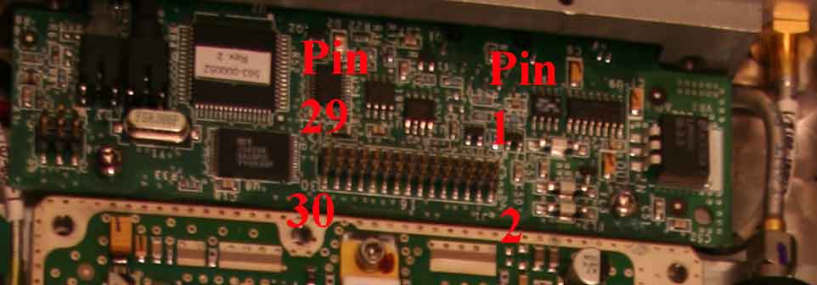

Pin | Static V | With RF V | Comment
1 | 8 | 8
3 | 8 | 8
5 | 2 | 5
7 | 1 | 1
9 | 0 | 0
11 | 3 | 3
13 | 0 | 0
15 | 0 | 2 | Disconnect this
17 | 7 | 7
19 | 0 | 0

Pin | Static V | With RF V | Comment
2 | 28 | 28
4 | 15 | 15
6 | .75 | 1.5
8 | 0 | 0
10 |  |  | 3V when LED light
12 |  |  | 3V when firing up, inhibits PA – pull up to 3V disconnect from board and earth for TX
14 | 0 | 4
16 | 0 | 0
18 | 0 | 0
20 | 0.5 | 0.5 | Disconnect and pull up to 3v to Control Board – No volts towards PA

PA With PSU PCB & No Screening

