The Bodger’s Guide to …………..
Recycling Aerial Facilities 900MHz quadrature hybrids for 23cms.

Introduction
During the development of my 23cms PA I had in mind to combine the finished design in pairs to produce higher power. A very efficient way to do this is to split the power and feed each amplifier in quadrature (90 degrees out of phase), and recombine the outputs via a further quadrature coupler such that the output powers combine in phase. The most straightforward quadrature combiner can be made using a rectangle of microstrip lines consisting of parallel 50 and 36 ohm lines as per Figure 1, and operation is described in detail on the excellent “Microwaves101” website http://www.microwaves101.com/encyclopedia/Branchline_couplers.cfm, from which Fig 1 is taken.

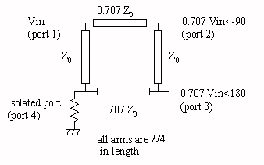
Figure 1 Quadrature hybrid combiner

Reasonably priced 23cms hybrid PCBs can purchased from the US, or home made by etching them on PCB material, but for any sort of power, FR4 tends to be lossy and overheat. There are examples of hybrid designs by Charlie G3WDG in Backscatter. The PCBs then have to be mounted in a box with suitable connectors.

The Bodger’s alternative
Recently, there have been a number of beautifully made hybrids for the 900MHz band appearing at rallies and microwave round tables. They were manufactured by Aerial Facilities in the UK. AFL, as they were known, is now part of Axell Wireless http://www.axellwireless.com. No data for the couplers is available on their web site as far as I can see, but from measurement, these hybrids are centred on around 900MHz. They are in heavy duty beige-painted milled boxes with four N connectors, and no other markings. They are worth the price for the box and connectors alone, but on opening them up you find a hybrid printed on high quality, low-loss 1.6mm Teflon board.
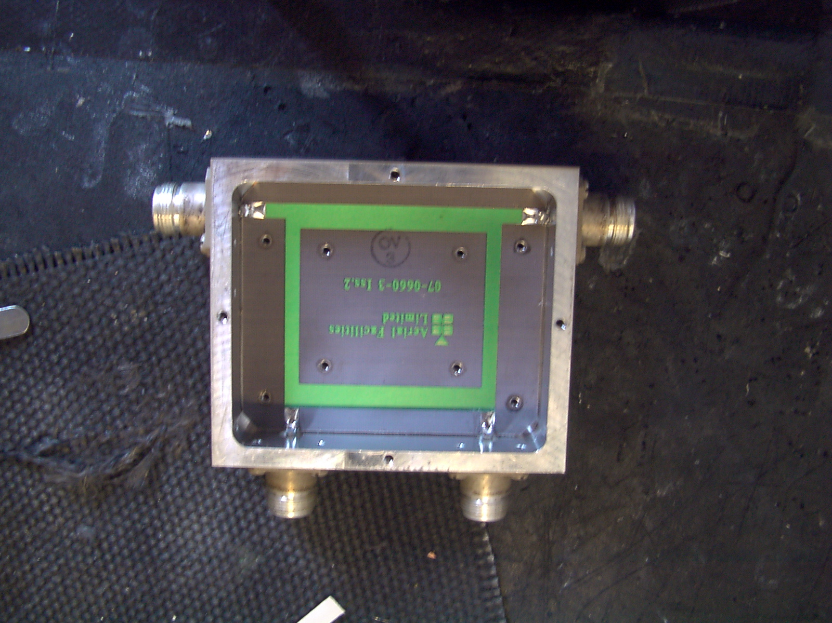
Figure 2 900MHz coupler

Unmodified, they will not work as 23cms hybrids, but you can use the PCB material and box to make one that will, and cope with at least 200Watts. It’s rather drastic, but you simply etch most of the original coupler away and stick on a new one using my old pal, adhesive copper tape. The first stage is to remove the green, solder resist with very fine emery paper. Then, using a PCB resist pen, cover the pieces you want to retain as per Figure 3. (In fact you can leave the top 36 ohm line in place as it is of the correct width). Before you etch, measure the widths of the lines carefully with vernier callipers, and note the positions of the wide (36 ohm) and narrow (50 ohm) lines. MAKE SURE you also tape over the reverse side ground plane with parcel tape , as solder tinning does NOT resist Ferric Chloride etchant !

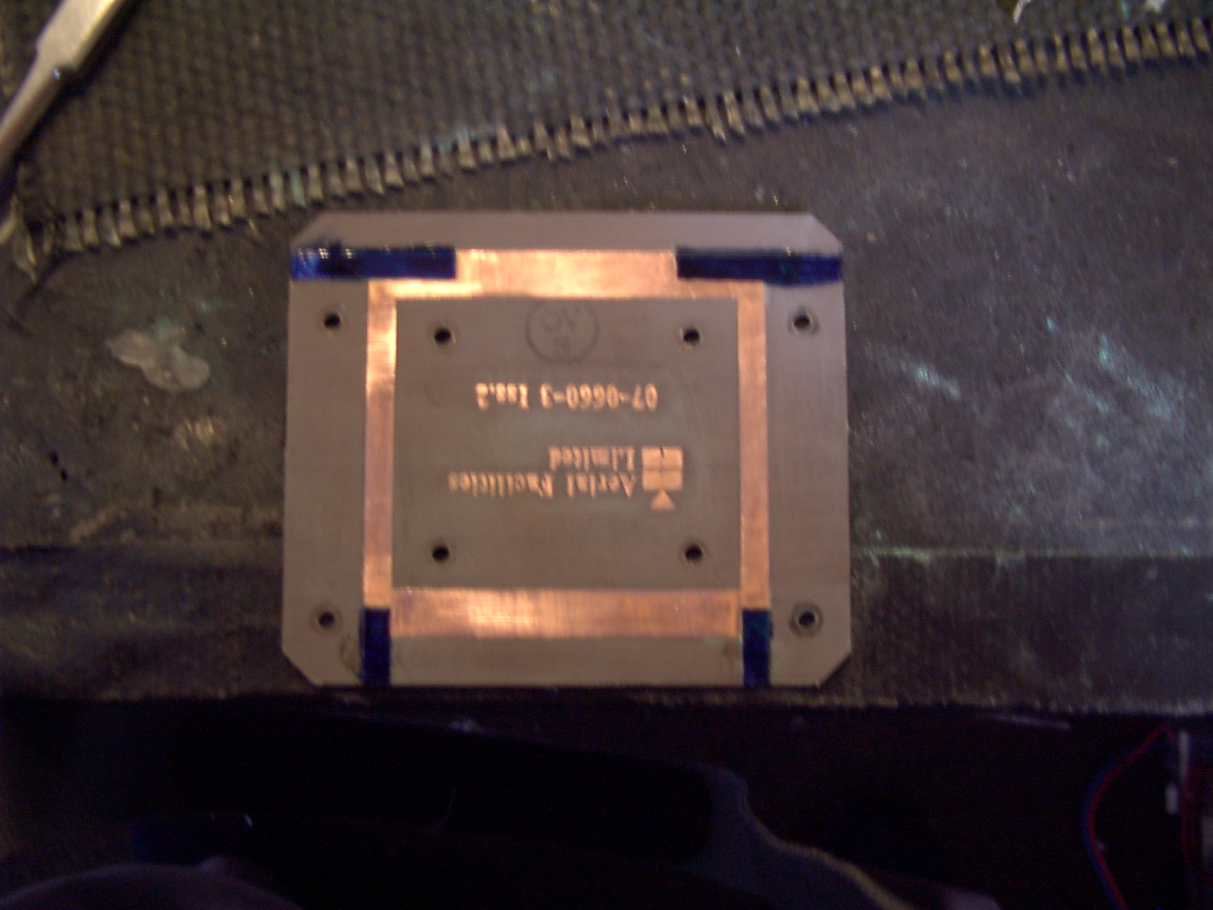
Figure 3 Coupler marked for etching

Once etched, you are left with just the connecting tabs to the four ports as in Figure 4

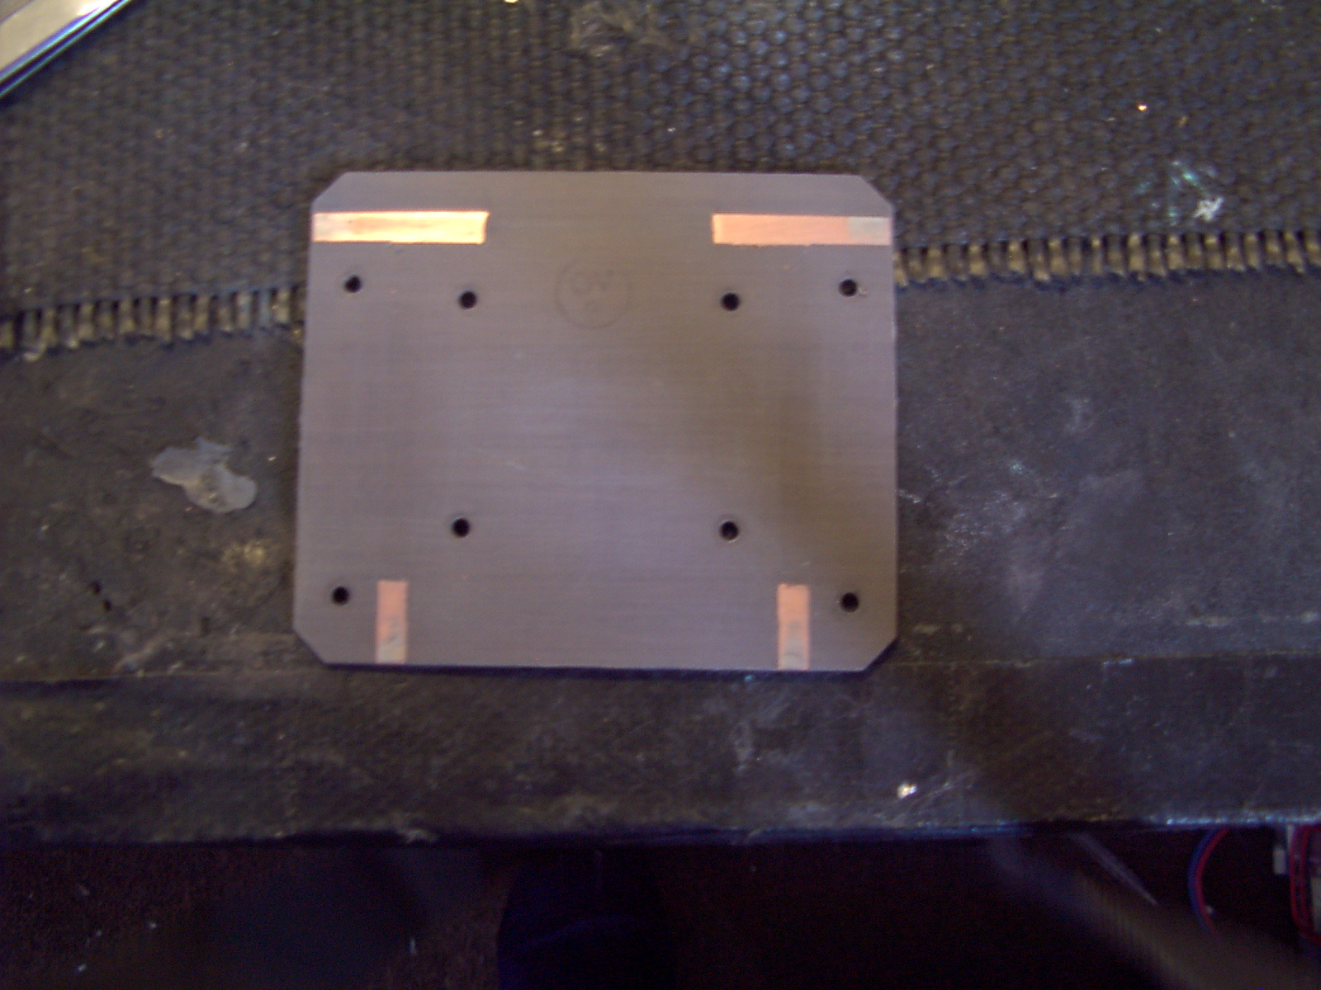
Figure 4 Etched hybrid
Cut the copper tape in to strips of dimension given in Table 1 and stick them down and solder together as per Figure 5. Note that they need to be measured very accurately using vernier callipers and cut and placed very carefully. The lengths are measured down the centre of the microstrip track, so measure them with your callipers from the right hand edge of the right strip to the left hand side of the left strip.

Line impedance | Width (mm) | Length (mm)
50 ohm | 4.46 | 41.2
36 ohm | 7.44 | 40.5
Table 1 Coupler dimensions for 1296MHz

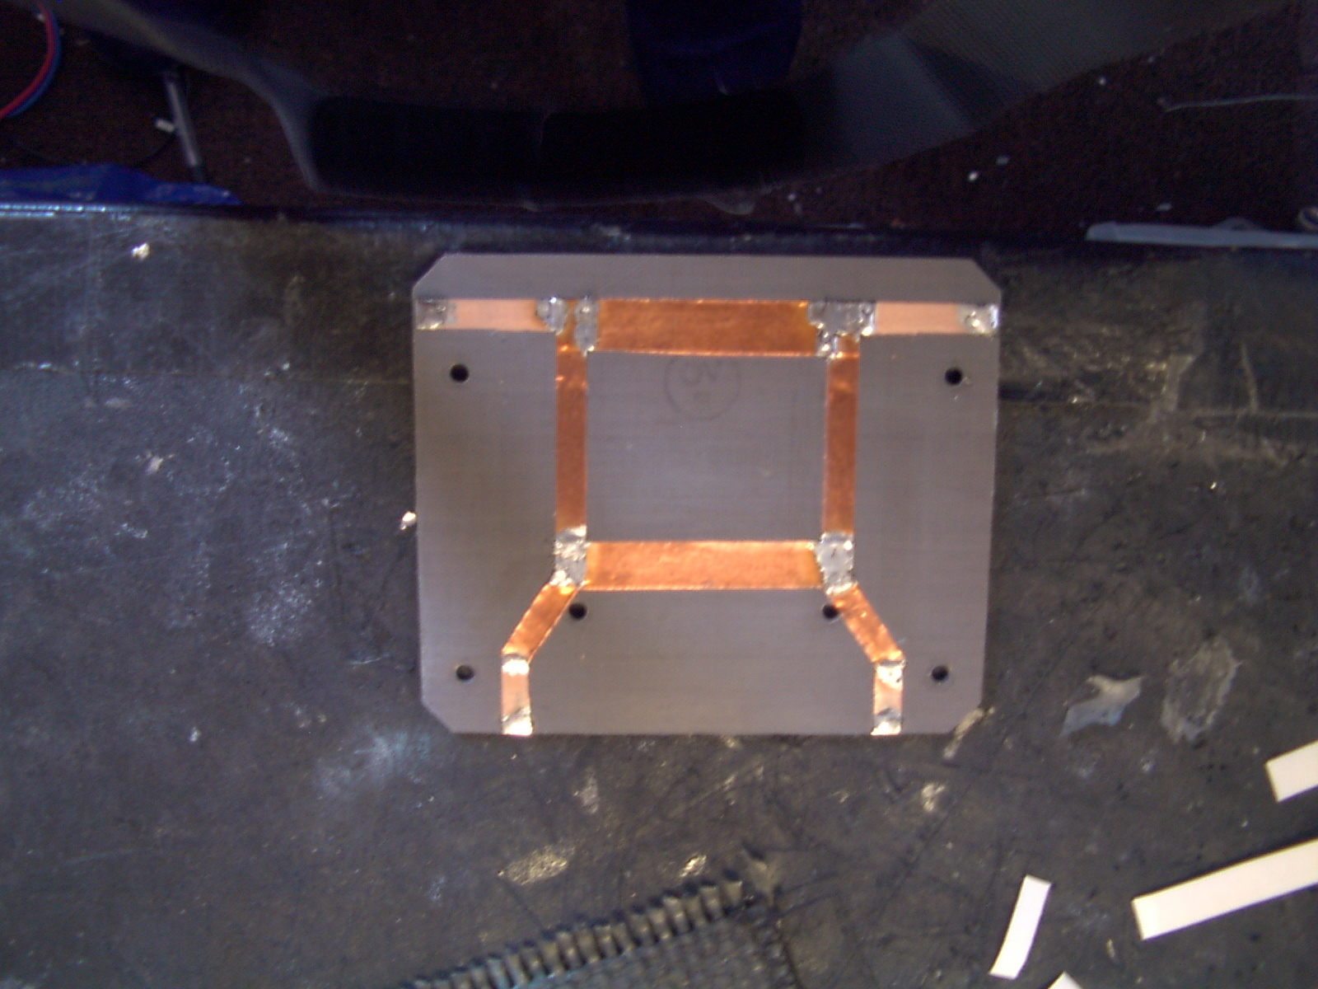
Figure 5 Finished PCB

Some couplers I have seen have the four port connectors coming out of opposite edges of the box rather than the layout shown in the pictures.

Adding a termination to one of the ports.
The PCB can now be replaced in the box using just four of the original screws, and an external N type load added and you are finished. If you wish to build in an integrated flanged power load it can be accommodated by cutting a piece of the board away and drilling and tapping two M3 holes in the base of the milled box as per Figure 6

.
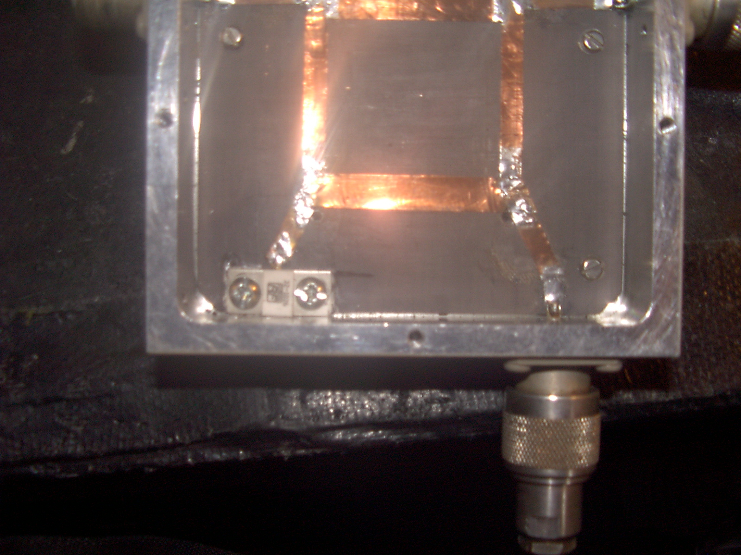
Figure 6 Finished hybrid with added 50 ohm load.

Typical test results at 1296MHz

Input return loss | >18dB
Isolation between split ports | >25dB
Insertion loss | <0.5dB
Amplitude imbalance between outputs | <0.3dB
Phase imbalance balance between outputs | <2.5 degrees

